**Lab: Cloud Watch Alarm & EC2 Action**

**Services Used: Cloud Watch, SNS, EC2**

In this exercise we configure cloud watch alarm perform custom ec2 action and send notification. Useful when monitoring EC2 resource usage and performing stop/reboot/terminate operations along with notifications.

1. Login to EC2 dashboard and check current CPU usage, Alarm status.

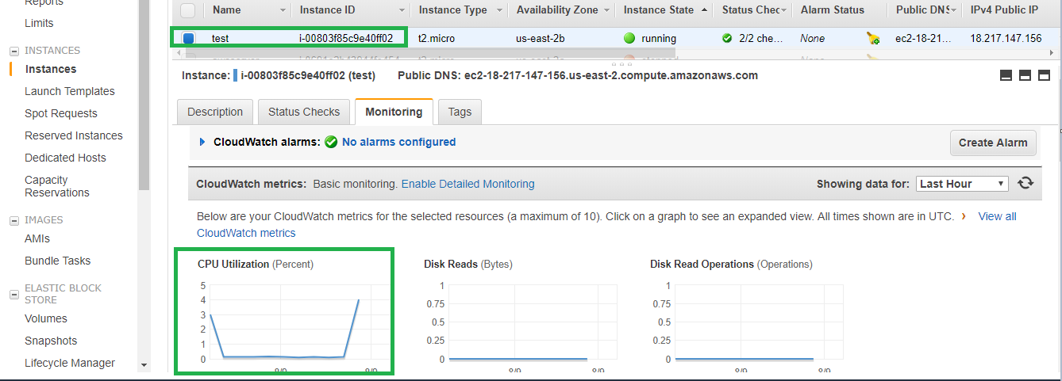

1. Monitor the CPU usage in the serer by logging to the instance.
2. Run stress command to increase the CPU Usage and load on the server.

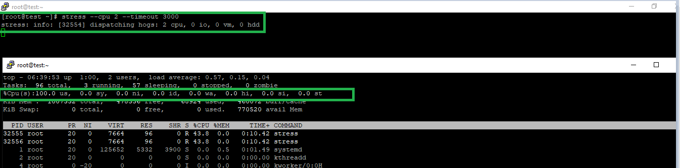

1. Open the Cloud Watch service
2. Under Alarms select Create Alarm.

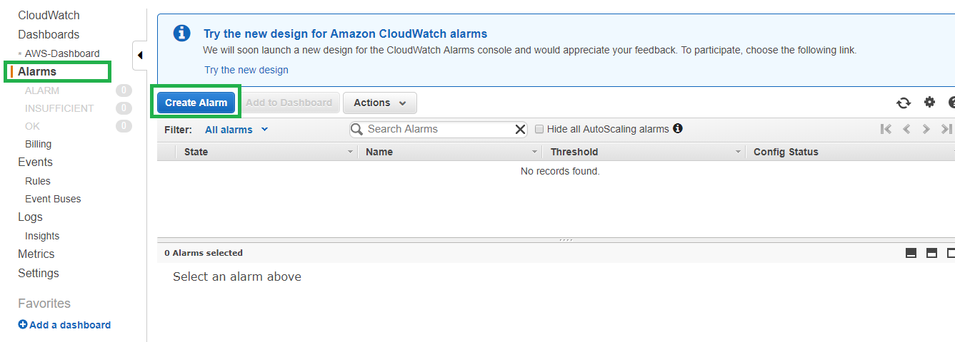

1. Select the metric by filtering the instance id of the EC2 instance that we are configuring alert.

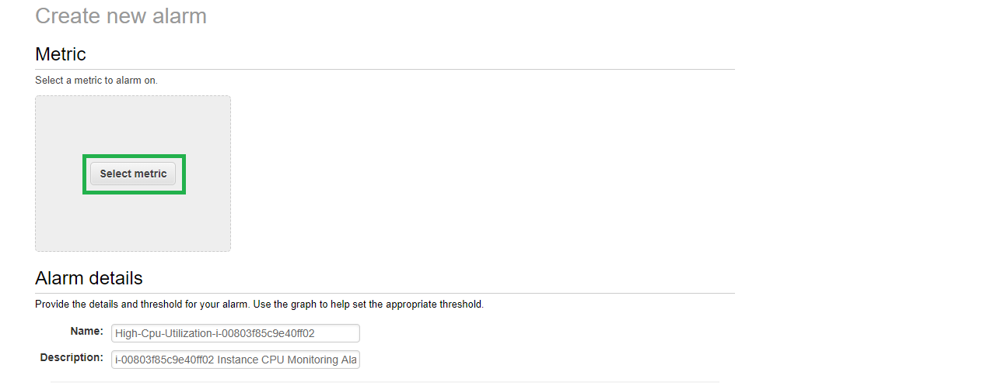

1. Select the CPU Utilization alert, ensure the right instance is selected.

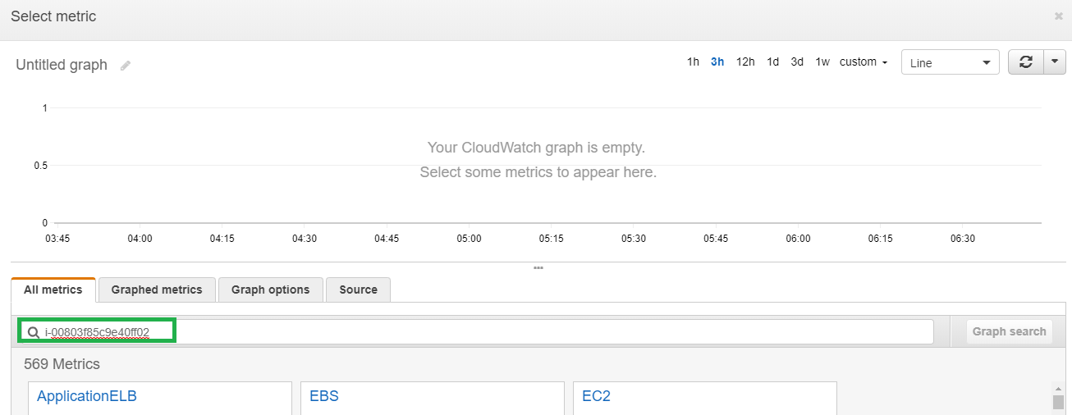

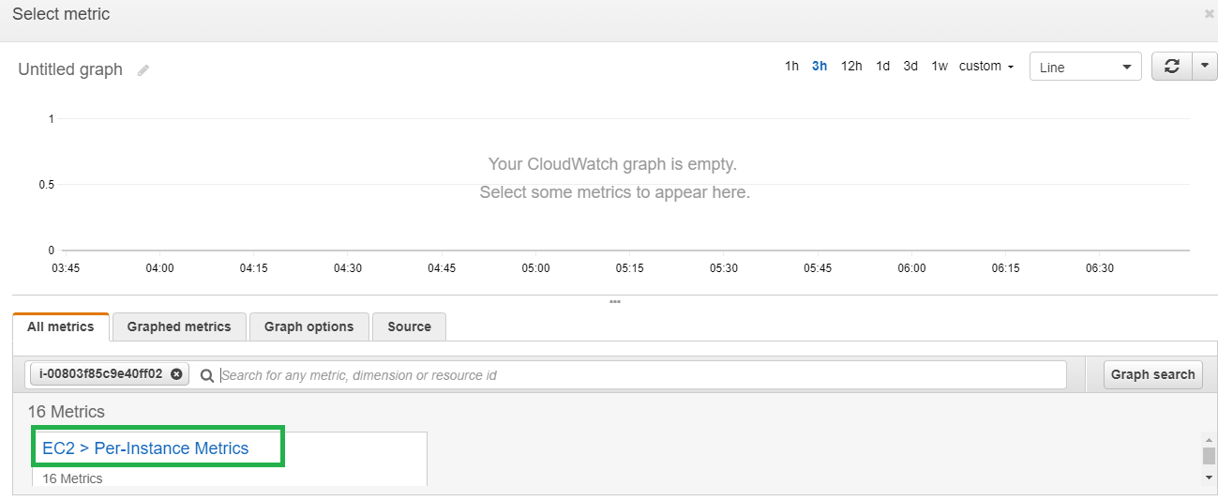

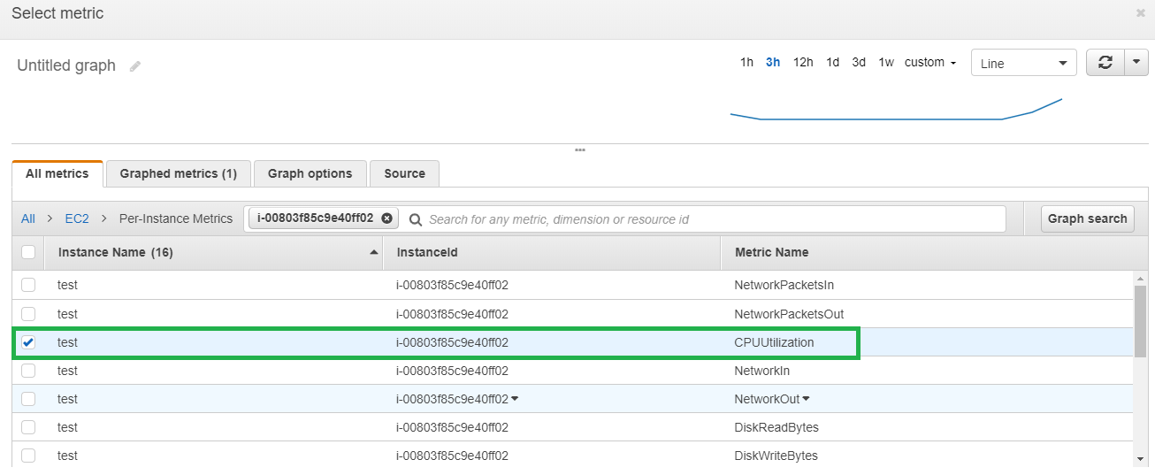

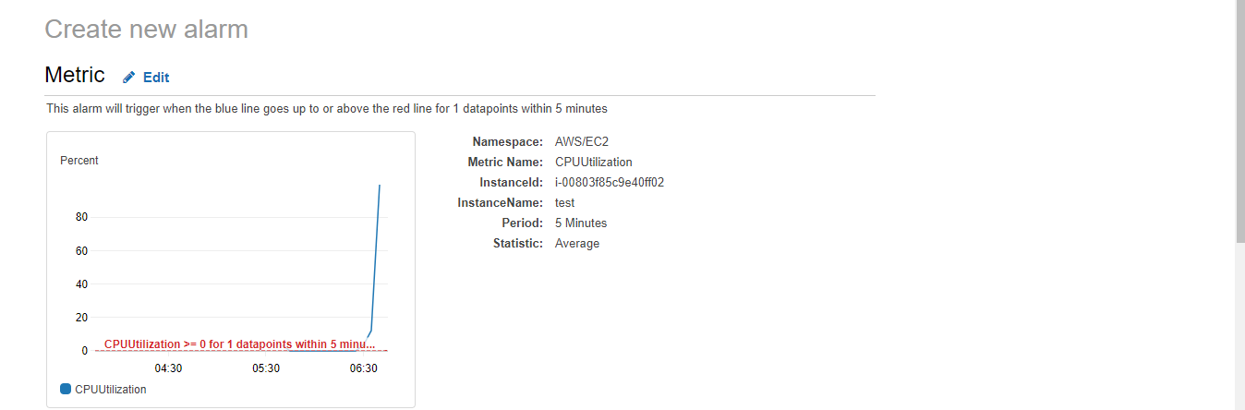

1. In the alarm details provide the cpu utilization is >= 80 percent for 1 data points. Which

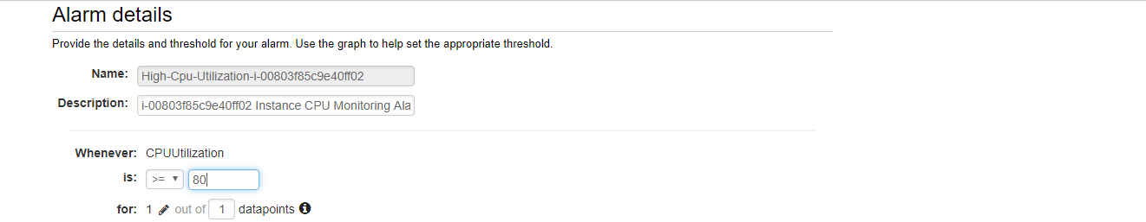

1. Select the notification option and select the SNS topic to which we are sending notification. For details on SNS check the SNS lab.

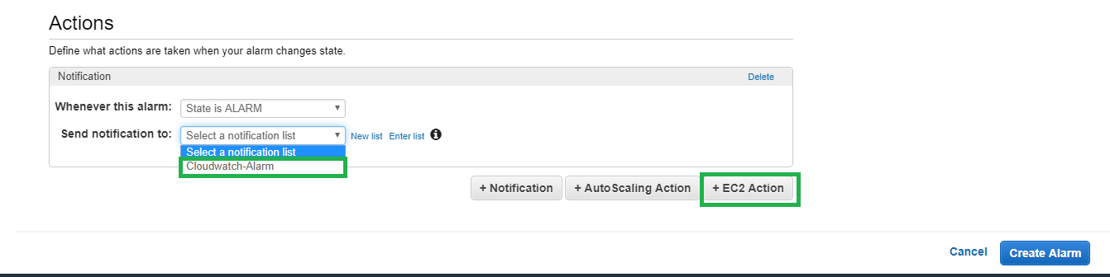

1. Click the Add EC2 Action and select state is alarm reboot this instance.

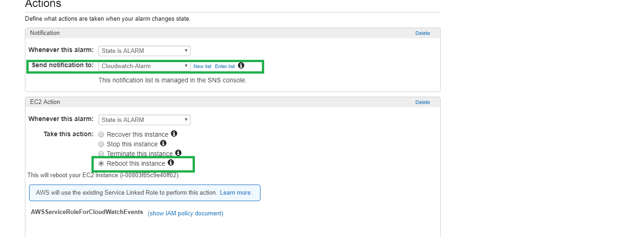

1. Create Alarm to complete.
2. Now the alert is created, it will take few minutes to gather the data and trigger the EC2 action.

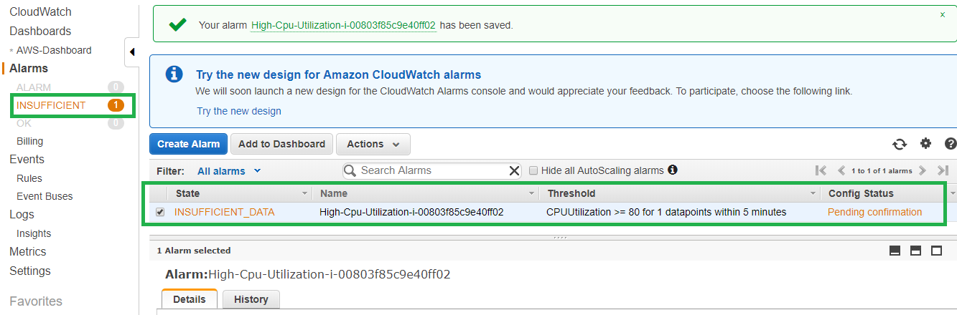

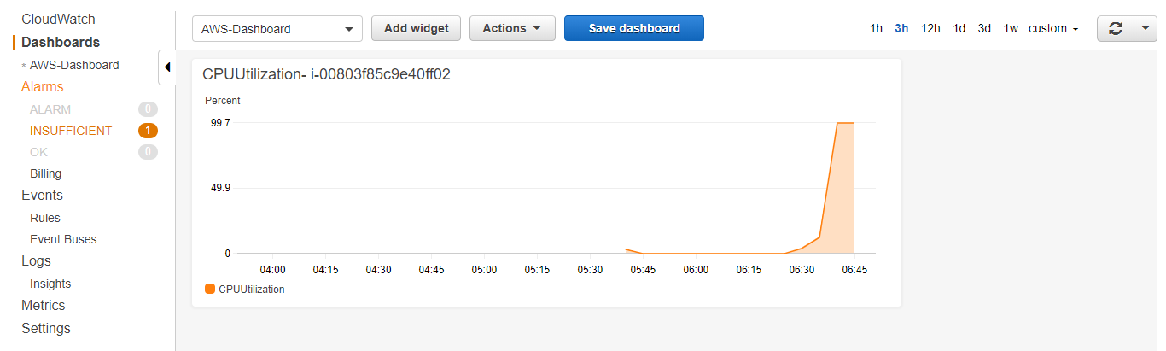

1. Now the alert has detected the CPU usage and alerting the EC2 status.

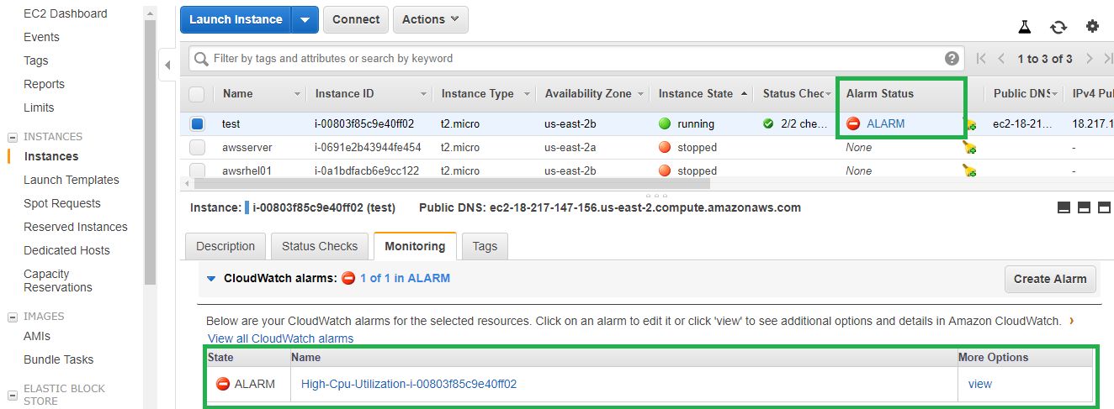

1. The EC2 action has been performed as a result of the alarm.

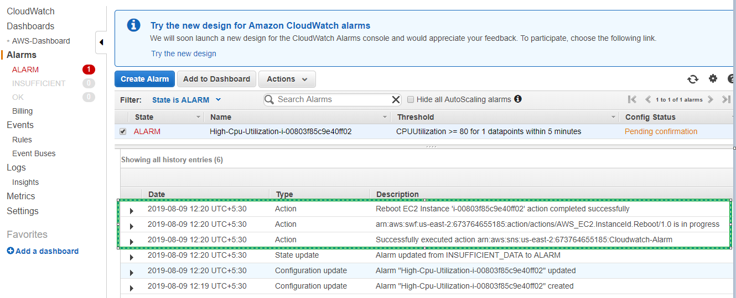

1. Now the EC2 instance is rebooted and cpu is normal.





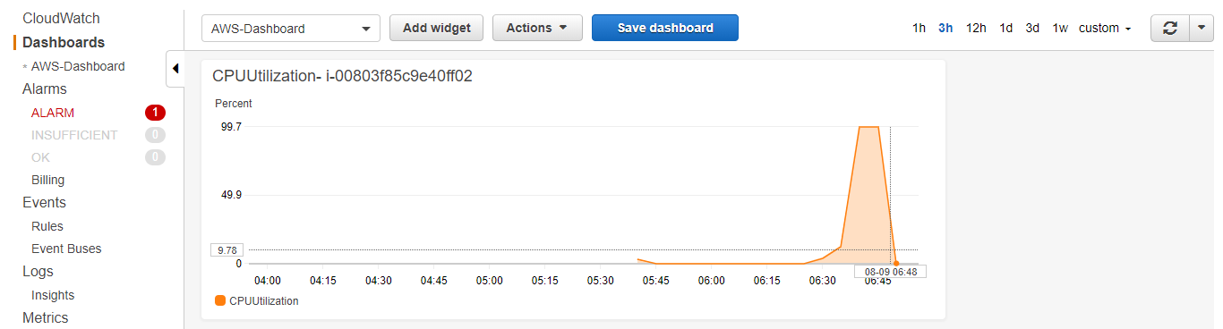

1. The cpu alert is also cleared and in Ok state.

